**VISHWAKARMA INSTITUTE OF INFORMATION TECHNOLOGY, PUNE**

**COMPUTER ENGINEERING DEPARTMENT**

**APRIL-MAY 2018**

**Synopsis**



**Team**

Team Members :

1. Pranjali Dhande

2. Nikita Kode

3. Rushikesh Khosare

4. Sandhyarani Biradar

Email-ID : pranju3012pd@gmail.com

Mobile no : 7768997632

Title :“ A SOLUTION TO TRACKING,TRACING AND CONTROLLING MOVABLE OBJECTS”

**Objective :**

Project related to tracking the vehicle using GPS and controlling movable objects.User is able to detect many things related to vehicle; alerts and notifications should be sent via application. Includes various reports generation.

**Abstract :**

GPS is one of the technologies that are used in a huge number of applications today. One of the applications is tracking your vehicle and keeps regular monitoring on them. This tracking system can inform you the location and route travelled by vehicle, and that information can be observed from any other remote location.

It also includes the web application that provides you exact location of target. This system uses GPS and GSM technologies. We can track each and every step of vehicle and gives the report to the owner. On the basis of these reports owner can take business decisions.

**Briefs about Contents:**

1. **Introduction :**

* Next generation Web Based GPS application.
* Uses GSM and GPS network
* It provides Real Time Automatic Vehicle Location, Tracking, **Fuel level and Fuel Theft Identification** as well as controlling the Vehicle.
* Tracing the Paths which the vehicle or the person travelled
* Generating various forms of reports to assist the Executive staff.
* Sending alerts/notifications via SMS or Emails.

1. **Technical Details :**

* Hardware
* Controller device consists of digital and analog inputs with GPS and GSM connectivity .
* Socket Listener
* Parser and Converter
* Web application.
* Web based GUI.
* Allows user to login.
* Use the application for monitoring, tracing, tracking, controlling vehicle, generating reports etc.

1. **Working :**

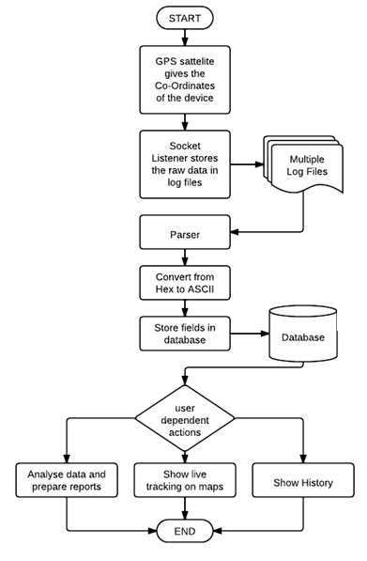

1. **Types of Alerts:**
   * 1. Door Open
     2. Ignition On
     3. AC ON / OFF
     4. **Fuel level Alert**
     5. Over Speeding
     6. Geo Fencing Alert
     7. Towing Alert

**Applications:**

* + - Mapping of the position of the device and showing it on Maps.
    - Showing the current status of vehicle on Dashboard
    - Showing Fuel Level
    - Tracing the complete path on the map travelled by the vehicle in particular span of time with alerts and reports.
    - Includes user defined geo-zones.
    - Used to track the Public Transport and give their location at each stop
    - Great solution for the big corporates to manage their vehicles
    - Used as an antitheft system
    - Personal tracking can be used to Track and locate people who are lost or are in danger.

**References/Bibliography:**

[1] “Integration of GPS and GSM for Determination of cellular coverage area”by A. D. Sarma, P. S. Ravikanth and D. Krishna Reddy.

[2] “Tracking System using GPS and GSM: Practical Approach” International Journal of Scientific and Engineering Research Volume 3, Issue 5, May-2012 ISSN 2229-5518.

[3] “Vehicle theft detection and tracking based on GSM and GPS” International Research Journal Of Engineering and technology (IRJET) ISSN 2395-0056.